Features of tax policy in Ukraine in the context of European integration

Iryna V. Kokhan
Department of Finance
Vasyl Stefanyk Precarpathian National University
76000, 57 Shevchenko Str., Ivano-Frankivsk, Ukraine
irina_kokhan@ukr.net

Veronika S. Dmytrovska
Department of Finance
Vasyl Stefanyk Precarpathian National University
76000, 57 Shevchenko Str., Ivano-Frankivsk, Ukraine
dmitrovska_veronika@ukr.net

Iryna Ye. Halushchak
Department of Accounting and Auditing
Vasyl Stefanyk Precarpathian National University
76000, 57 Shevchenko Str., Ivano-Frankivsk, Ukraine
iryna.galushchak@gmail.com

Abstract. The tax problem is one of the most complex and controversial in the world. The global practice of preserving the national economy shows that taxes are a major source of income to the budget and, therefore, funding for social and other national programs. The issue of Ukraine's integration with the EU is very relevant and strategic today, in the context of which it is equally important to harmonise tax policy in Ukraine in line with EU norms. The main purpose of this article is to identify the features of tax policy making in Ukraine at the present stage and to adapt it to the process of European integration. The methodology of comparative analysis of the domestic tax system and its legal base in the countries of the European Union, as well as statistics on the tax base and its dynamics, was applied as the main approach. According to the results of the analysis, the main problems of functioning of tax systems of Ukraine and the EU countries have been identified, and the directions of their solution are suggested. Of further interest is such a line of research as a careful comparison of legislative support for tax policy in Ukraine and EU countries in the context of the implementation of the relevant norms in the domestic legislative framework.

Keywords: taxes, tax policy, tax revenues, European Union, European integration, tax reform, fiscal reserves.

Introduction
Taxes are not only the main source of replenishment of state revenues, but also one of the main levers of the state's influence on the market economy. Therefore, creating an effective tax system is one of the most important problems of any country [1].
Effective tax policy organisation is the key to sustainable economic development in the country. In the context of Ukraine's strategic course for integration with the EU, one of the topical issues is the harmonisation of tax policy in Ukraine and its unification with EU norms. This process is a difficult task as tax policies of Ukraine and EU countries are based on different principles.
It is extremely interesting for Ukraine to experience tax reform in the EU countries, which will allow choosing its own tax strategy taking into account the positive and negative consequences of tax policy making [2].
It should be borne in mind that tax policy standardisation is preferred in EU countries. At the legal level, it is the duty of EU countries to comply with common rules and regulations in the field of taxation [3]. National tax law should not contravene EU tax law [4]. However, a single unified tax system in the European Union is not created because of the difficulty of reconciling a common tax policy with the national interests of each country. Each country's tax policy is based on national priorities, which gives individuality to the tax system in each country [5, p. 18]. As a result, the national tax systems of the countries at the present stage are directed according to the vectors of pan-European integration.
Such domestic scientists as Bogatyryova E.N., Vasyutinskaya L.A., Veliksar T.I., Gorobey K.D., Korneva T.N., Kotsyrubenko A.N., Popova V.V., Tsymbalenko Y.Yu. were engaged in the study of this issue
Dmitrenko G.V., Kovalyova O.O., Mrinskaya O.V., Salnik O.M., Slepets V.M., Yashchenko K. researched exactly the taxation system in the context of European integration processes and the situation in Ukraine.
This issue is relevant among experts from the CIS countries, in particular: Abakarova R. Sh., Volkogon S.A., Lukyanova I.A., Naumchik S.O., Slatvinskaya M.A., Filipovich E.S.
This issue is actively covered by foreign scientists: Alesina A., Bury F., Wiener H., Griben G., Lorets S., Tabelini J. and others.
Almost all authors agree that taxes play a crucial role in regulating the economy and implementing macroeconomic policies, accounting for up to 90% of the revenue part of the state budget.
Despite the considerable amount of research on the subject and the various tax policy improvements developed at both national and intergovernmental levels, the issue still needs to be developed with effective strategies and remains unresolved. In Ukraine, this problem is relevant to the issue of its incorporation into the declared European integration development strategy.

Materials and Methods
The methodological basis of the study was analytical and statistical methods of analysis. General and special methods have been used. The main provisions of the legislative framework at the international, national level and in the EU are examined. The methodology used made it possible to outline the main directions of optimisation of the tax system and its implementation to EU tax principles. The methods used allowed us to obtain reliable and valid conclusions and results.
Comparative analysis was used as one of the main methods of analysis, which made it possible to compare the domestic tax system with the legal basis for regulating the object of study in the countries of the European Union. It also compares statistics on the tax base and its dynamics.
The descriptive method allowed presenting the results of the study in a logical sequence.
The study also used statistical methods, methods of economic analysis, synthesis, analogy, system and classification.
The method of synthesis solved the set research tasks through its application to primary sources on the subject. The application of the analytical method to the primary source data made it possible to make recommendations regarding the implementation of the national tax system to European legislation; identify the main areas of experience in tax policy reform and the conditions justifying the application of certain measures, the compliance of the international tax base with the specificities of national systems and EU tax law as a whole.
Methods of induction and deduction were used to analyse the content and structure of legislative texts, the characteristics of legal norms in the context of research topics.
In the course of the analysis, a historical method was used to investigate the process of the EU tax system development.

Results and Discussion
The Treaty on the Functioning of the European Union (TEU) does not distinguish tax policy as a separate line, but it is one of the most important components of both the internal and external policies of the European Union [6]. At the same time, it contains several sections on its regulation: the main tax provisions (Articles 110-113) and on the harmonisation of legislation on taxes, excise duties and other forms of indirect taxation; a section on approximation of laws (Articles 114-118), which covers taxes that have an indirect impact on the creation of the internal market, with fiscal provisions that do not fall under the ordinary legislative procedure; other provisions concerning tax policy, free movement of persons, services and capital (Articles 45-66); provisions on improved cooperation (Articles 326-334) on tax matters [7]. Although the European Union is largely based on political motives, it prefers economic functioning and coordination to its functioning and coordination. Ensuring the declared freedoms in Article 3 of the Treaty on European Union requires considerable policy coordination, including taxation, and tax harmonisation, even if the TEU does not provide explicit taxation rights at European level.
Tax coordination refers to the imposition of taxes when countries or groups of them build internal tax systems compatible with the objectives of the Union, as formulated in the TEU. Countries deliberately relinquished part of their autonomy in tax matters. Reconciliation is seen as a closer coordination that leads to almost identical or similar tax systems, tax bases and tax rates within the Union.
The main areas of tax integration in the EU are harmonisation of VAT and excise duties and the unification of company taxes. The purpose of transferring tax revenues to EU bodies has not been established. Member States' revenue from tax collection continues to flow to their national budgets, except for some of the VAT that is transferred to the Union's single budget. The EU does not create a single tax space that impedes the functioning of the single internal market. Legislation on all types of taxation (direct and indirect) is adopted by the EU Council unanimously, drawing up directives that specify the purpose and timing of work. The specific methods for their implementation lie within the competence of the national authorities responsible for adopting the relevant laws.
Countries approaching EU accession should fully assimilate EU law and refrain from taking any measures contrary to EU law [8]. This issue also applies to Ukraine, which has already legislated this task [9].
The development of integration processes in Europe for accession to the European Union requires a common tax policy and an improved tax system, with a gradual transition to a common tax regime based on the following principles [10]:
- national tax policies should not impede the free movement of products;
- the country's tax policy should not impede the free movement of labour;
- the country's tax policy should not be contrary to EU policy.
The EU's tax policy strategy is explained in the Commission communication “Tax policy in the European Union – Priorities for the years ahead”. The right to impose, remove or adjust taxes remains in the hands of the Member States. Each Member State is free to choose the tax system it deems most appropriate, provided it complies with EU rules.
Each country's tax policy consists of a system of measures that take into account national priorities through measures to protect fiscal sovereignty. EU institutions and bodies, as well as the relevant structures of the participating countries, are the subjects of the development and implementation of EU tax policy. The two-tier system allows:
- to harmonise tax legislation in EU Member States;
- to remove barriers to the EU internal market;
- to ensure the fundamental freedoms declared by the EU Treaty: the movement of goods, persons, services and capital;
- to reform tax systems to improve efficiency and equity;
- to remove tax obstacles to cross-border economic activity;
- to prevent unfair tax competition from Member States' jurisdictions;
- to eliminate tax discrimination in the EU internal market;
- to avoid double taxation;
- to facilitate cooperation between tax administrations concerning provision of control;
- to fight against tax offences.
According to European Commission studies in 2018, the taxation system of the Member States of the European Union is characterised by stability [11]. The main strategic vectors are aimed at promoting investment and employment, reducing tax fraud, tax evasion, eliminating income inequality and ensuring social justice. The Commission's annual activity report presents the EU's achievements and tax issues that need to be addressed: fight against tax fraud and aggressive tax planning was a priority of policy in the past legislative period (2014-2019). Work is underway to reform the corporate tax mechanism to make EU corporate taxation fairer and better adapted to the current digital economy in the internal market, and developing a definitive VAT regime has become another policy priority.
Enhanced tax policy coordination will ensure that Member States' tax policies support the broader goals of EU policy, as defined in the Europe 2020 Strategy for Sustainable and Comprehensive Growth and in the Single Market Act.
Despite the high level of standardisation of this area, statistics, which differ significantly by country, also indicate the necessity of choosing a tax strategy among EU countries.
The most commonly used relative indicator of the tax base characteristic is the indicator of the share of taxes in the country's GDP. At the beginning of 2018, the share of taxes in GDP in the EU countries averaged 40%, as in the previous year (Fig. 1).

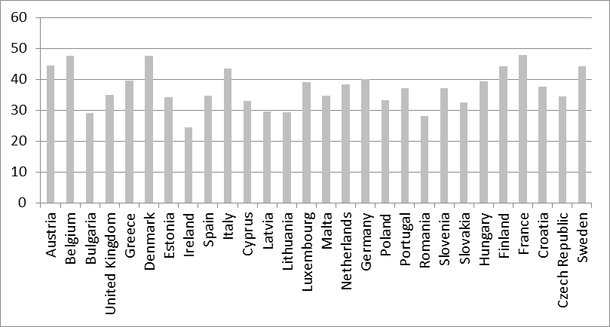
Fig. 1. The share of taxes in GDP in the EU as of January 1, 2018.

At the same time, there are variations in this indicator among EU countries. France, Denmark, and Belgium (over 47%) are the leaders in terms of share, the following countries are outsiders: Ireland (24.4%), Romania (28.0%), Bulgaria (29.0%), Lithuania (29.4%) and Latvia (29.5%).
In Ukraine, the share of this indicator is almost at the level of the countries with its lowest level. Significant growth has taken place in recent years (2017 and 2018). In the whole 12 years, this figure increased by 40%. Fig.2 presents the dynamics of tax revenues to the state budget in% of GDP.
For the period 2007-2015, the share of tax revenues in GDP is characterised by relative stability with slight fluctuations. After 2015, there is a trend towards an increase in the share, which until 2018 is somewhat stabilised. Overall, the growth for 2007-2018 was 9.4%.

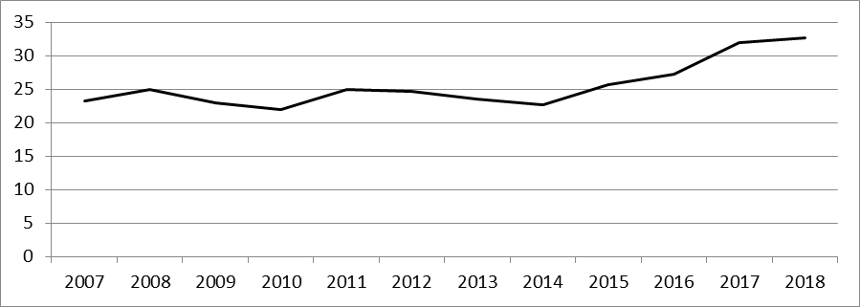
Fig.2. The dynamics of tax revenues to the state budget of Ukraine in 2007-2018, % GDP

Direct taxation in the EU includes taxes levied on income, wealth and capital on both individuals and corporations. Personal income taxes (PIT) are not covered by EU provisions: this area is more in line with the case-law of the European Court of Justice. EU action on corporate income tax is more empowering, but it mainly concerns measures to regulate the single market.
Indirect taxation consists of taxes other than income or property: VAT, excise duties, import and energy charges, environmental taxes. These types of taxes have been harmonised in the first place and more fully than direct taxes, as EU tax principles must ensure the smooth functioning of the single market.
Compared to Poland, which has almost the same level of tax revenue as a percentage of GDP, the structural distribution between direct and indirect taxes differs significantly. Thus, Poland prevails by 9% in terms of the share of indirect taxes, when in Poland direct taxes are 23%, while in Ukraine 40%. For other types of taxes (rent, customs duties, etc.), they are twice as high in Poland (13%) than in Ukraine [14]. In 2019, a decision was made to exempt income tax for youth under 26, which is more than two million people [15].
However, the tax revenues themselves make up the bulk of the revenue of the state budget of Ukraine – 62% (UAH 623 billion as of January 1, 2019 (the other 38% – customs revenues. At the same time, 22% of tax and customs payments go to local budgets; 38% – to customs, 40% – to the central budget.
The structure of tax revenues is much higher than VAT (Table 1). By a considerable margin (three times), the second place is occupied by income tax, and the third place is practically at the same level – PIT.

Table 1. The structure of tax revenue as of January 1, 2019. [16]
Tax | UAN billion | %
Import duty | 27 | 3.62
Excise duty (importation) | 46 | 6.17
VAT (importation) | 295 | 39.54
Rent | 39 | 5.23
Excise tax (domestic) | 71 | 9.52
VAT (internal) | 79 | 10.59
PIT | 92 | 12.33
Income tax | 97 | 13.00

In terms of VAT, the main charge is on the value of imported goods, i.e. the domestic market plays a significant role in the use of foreign producers. This model contradicts the policy of protection of the domestic producer declared in Ukraine, since the reduction of imports leads to a significant increase in the budget deficit due to the reduction of VAT.
The current mechanism of VAT refunds leads to stimulation of export of raw materials abroad due to the guarantee of the exporter receiving a refund of 20% by the state [17]. This model causes the country's loss of its natural resources and a shift towards the raw nature of the economy.
As a result, the payer is the end consumer who pays VAT in the structure of prices of goods, both domestic and foreign origin (Fig. 3).
Up to UAH 130 billion is spent annually from the budget, and the total amount of VAT (minus compensation) is only up to UAH 80 billion.
Insignificant amounts of corporate income tax indicate the inefficiency of its application, which has long raised the question of its replacement (turnover tax or capital tax). With regard to this type of taxation, it is advisable to make use of the experience of the European Union countries.
For comparison, the population generates a tax revenue of 22%, which is more than twice the proportion of the income tax. It takes into account that the income tax on the income of individuals also goes to the local budgets to a greater extent – UAH 123 billion. But if you take all the amounts of direct and indirect tax revenue from corporate payers, the total amount reaches 39%.

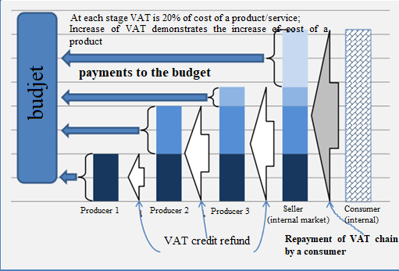
Fig. 3. The scheme “VAT chain” (internal consumer) [18]

Regarding local budgets, according to 2018 data, it can be stated that almost 70% of them are formed by the personal income tax, the same level amounted to a property tax and a single tax – 16% each. These data may indicate a high level of shadowing.
Similarly, with regard to excise duties, the amounts of deductions for which clearly do not correspond to the potential of production and consumption of excisable goods. The problem of counterfeiting excise goods in million volumes has been acute for several years.
A similar situation is with respect to rent payments. Given the large volumes of natural resources and mineral resources in Ukraine, the available rents for production are very meagre (about UAH 40 billion annually). It turns out that the high-yielding gas industry pays taxes at the conventional FOP (6 and 5 %, respectively). It also contributes to the transformation of Ukraine into a raw material appendage of other countries. The flagships of the formation of the revenue base are mining and processing industries, and such leading and potential payers as agriculture (only UAH 23 billion) and construction (only UAH 13 billion) are outsiders compared to them.
Thus, it can be stated that the model of rent, commodity, corruption economy and tax policy has been developed and continues to operate in Ukraine for decades. The taxation system is based on the internal market, the end consumer and the population. Therefore, it is clear the opposition to the bill “On Amendments to the Tax Code of Ukraine concerning the improvement of administrative taxes, elimination of technical and logical inconsistencies in the tax legislation” No. 1210, which provides for an increase in the rent for the extraction of ore [19].
New government every time introduces a “new tax reform”, but sometimes it does not end or contradict previous innovations. Frequent changes in the government resulted in the branching of the tax system, the lack of comprehensive reform of the tax system and the introduction of a systematic transformation of the fiscal model.
Thus, changes in the VAT tax mechanism, optimisation of excise goods and rent payments, changes in corporate and individual income tax policies can be determined tax revenue growth reserves in Ukraine. The main areas of reform are a significant reduction in direct taxes (income tax and personal income tax) amid an increase in some types of indirect taxes (excise duties, import VAT) and other tax and non-tax levies (rents for natural resources, excise duties and excise duties) customs duties on commodities).
Foreign experience of transformational changes in socio-economic development shows that in almost all countries these changes were preceded by significant changes in the fiscal model. The Korean miracle or Polish transformation came about through some fiscal measures that allowed for revenue and investment to rebuild the economy. In a developed economy with a stable business environment, it is possible to increase the tax pressure on the corporate sector. In Ukraine, however, the transformation process has started on the contrary and continues its destructive effect on the business environment.
Significant fiscal pressure does not only destroy monopoly-owned financial entities. They are kept in a favourable position by receipt of monopoly rent, through political lobbying of their interests in government and receiving significant funds from redistribution from the budget of tax revenues in the form of VAT refunds, development grants, innovations, etc., or through government procurement.
At the same time, it is impossible to interpret the EU tax system as fully effective and copy its provisions to the national system. After all, it has many disadvantages, ineffective provisions and unresolved issues. In particular, one of the pressing problems in the EU area today is the migration problem. In particular, the problem of a huge influx of migrants into a number of EU countries, including Member States. This problem is to some extent also caused by imperfect tax policy.
The question today is whether the Treaty on the Functioning of the EU contains provisions to restrict or prohibit incoming flows of migrant and refugee workers. One of the measures in this area is to limit the factors that make these categories attractive, first of all, to deprive (or limit) their right to tax relief and certain types of social benefits.
It should be noted that, for example, the UK suffers from flows from EU countries (mainly from Romania and Bulgaria), because the UK social system is significantly different from the social assistance model in other Member States. So, in many EU countries, there is no equivalent to housing assistance and tax benefits for workers. In most European countries, Britons are not eligible for benefits until they make a certain contribution to the social security fund, while migrant workers from the EU in the UK have access to many benefits and tax benefits from the first day of their stay in the UK. As a result, many migrants (especially families with young children) travel to the UK through these differences in social legislation, get paid jobs for work and tax benefits [20; 21].
In this respect, it is also advisable to take on board the experience of other European countries in setting tax exemption limits within 3-5 years.

Conclusion
Tax policy imperfection in the Eurozone is also evidenced by problems of regulation that are similar to international and national in some countries. The international competition for mobile factors of production – labour and capital – has led to the development of tax systems in many countries in the direction of shifting the tax burden from these factors of production to consumption and natural resources. This has led to the following trends in tax reform: the stabilisation of value-added tax rates in many European countries and the sufficiently high taxation of goods that have a negative impact on human health and the environment, as well as green tax reforms, during which there was an agreed multi-vector change in the rates of environmental taxes and contributions to social funds.
Ukraine's choice of a European integration path raises issues of harmonisation of Ukraine's tax policy with that of the EU member states.
Holistic integration into the European development process in the context of a new round of globalization and changes in the field of international taxation lead to the need to ensure effective tax systems, both in the EU and in Ukraine. The need to overcome tax abuses and to ensure a level playing field in the international space is causing new transformational trends.
Increasing the efficiency of tax systems in the EU and in Ukraine today depends on a number of recent trends in the globalised world that have implications for taxation: such as the digitalisation of the economy and the technological breakthrough, changing patterns of globalisation, exacerbating demographic and environmental problems.

References
- M.F. Safonova, D.S. Reznichenko, M.V. Melnichuk, A.K. Karaev, S.F. Litvinova. Taxes Harmonization Features in the European Union Countries. International Journal of Economics and Financial. – 2016. – No. 6 (58). – РР. 154-159.
- Sokolovskaya A.M. Tax policy in Ukraine in the context of the trend of tax reformation in the EU / A.M. Sokolovskaya, T.V. Koshchuk // Finance of Ukraine. – 2012. – Is. 1. – P. 94–115.
- Dubovik O., Convergence of value added tax mechanisms of Ukraine and the European Union / O. Dubovik, T. Kovalchuk // Scientific Bulletin of the Odessa National Economic University. – 2016. – No. 8 (240). – P. 16–18.
- Demidenko L.M. Tax policy of the European Union // Scientific Papers of the Scientific Research Institute. – 2007. – Is. 3. – P. 87–95.
- Gorobei K.Y., Tsymbalenko Y.Y. The current state of tax revenues in the context of GDP of EU and Ukrainian countries // Bulletin of KNUTD. – 2018. – No. 1 (119). – P. 18-26. – P.18.
- European Union tax law [Electronic resource]. – 2016 – Access Mode: http://ukraineprav.com/international_law/european_union_law/data-right-evropeys%60kogo-soyuzu.
- Consolidated version of the Treaty on European Union / Document 12012M/TXT. – Access mode: https://eur-lex.europa.eu/legal-content/EN/TXT/?uri=celex%3A12012M%2FTXT.
- Popova V.V. Improvement of the tax policy of Ukraine in the conditions of European integration // Abstract of dissertation on the state government. – K., 2009. – 23 p.
- Law of Ukraine “On the National Program of Adaptation of the Legislation of Ukraine to the Legislation of the European Union” of March 18, 2004, No. 1629.
- Yakubenko V.P., Motornaya A.S., Ovcharuk O.S. Ukraine in the field of approximation of taxation to European standards. – Access mode: http://intkonf.org/yakubenko-vp-motorna-as-ovcharuk-os-ukrayina-u-sferinablizhennya-opodatkuvannya-do-evropeyskih-standartiv
- Fact Sheets on the European Union. – 05.2019. – Acces mode: http://www.europarl.europa.eu/factsheets/en/sheet/92/general-tax-policy
- Share of taxes in GDP of the European Union and Ukraine [Electronic resource]. – Access mode: http://edclub.com.ua/analityka/statystykachastka-podatkiv-u-vvp-yevropeyskogoyevropeyskogo-soyuzu-ta-ukrayiny.
- Budget of Ukraine [Electronic resource]. – Access mode: http://cost.ua/budget/revenue.
- Poland – Income Tax. – Asses mode: https://home.kpmg/xx/en/home/insights/2011/12/poland-income-tax.html.
- Poland exempted young people from income tax. – Access mode: https://zn.ua/WORLD/polsha-osvobodila-molodezh-ot-uplaty-naloga-na-dohody-325705.
- Official Website of the State Fiscal Service of Ukraine. – Access mode: http://sfs.gov.ua.
- Tax Code of Ukraine: Law of Ukraine No.2555 of December 2, 2010-Section V.
- [18] Didenko S. Assessment and mechanism of VAT refund in Ukraine: how it works // ua.news, 13.05.2019. – Access mode: https://ua.news/en/otsinka-ta-mehanizm-vidshkoduvannya-pdv-v-ukrayini-yak-tse-pratsyuye.
- Draft Law on Amendments to the Tax Code of Ukraine on Improving Tax Administration, Removing Technical and Logical Discrepancies in the Tax Legislation. Registration No. 1210 dated August 30, 2019.

Net migration to UK rises to 333,000 – second highest on record // ВВС, 26.05.2016. Asses mode: http://www.bbc.com/news/uk-politics-eu-referendum-36382199.
- Tax Reform in Ukraine and the Republic of Belarus: Analytical Studies: monograph/ Ed. V.G. Baranova, O.E. Dubovik, E.F. Kireeva. – Kharkiv, 2016. – 240 p. – P. 19

