Distribution of radiation defects on thickness of IV-VI thin films at α-irradiation
D.М. Freik, Ya.P. Saliy, N.Ya. Stefaniv
Precarpathian National University
Irradiation of materials by easy particles with energy 0,1 - 10 MeV plays an important role at creation of semiconductor devices. The decision of problem of control of semiconductor properties of material by α-irradiation is impossible without understanding of the mechanism of interaction of irradiation with a solid and influence of defects on his properties. Exactly defects in undoped films of lead chalcogenides and tin are responsible for their semiconductor properties.
At rather large energies of falling α−particles, when maximum of profile of damages is on a depth of few microns, for it analysis it is possible to use the method which is based on the change of electrical resistance of thin sample. Thus, to define the degree of damages with depth for weakening of flood foils of different thickness are putted.
The calculation of profiles of ionization loss and damages of crystalline lattice under the action of monoenergetic α-particle beam is actual for the tasks of modification of properties of semiconductor materials; for development, choice of the regimes of exploitation and radiation firmness of detectors of ionizing radiation.
An ionization loss of charged particles in semiconductor is mainly spent for formation electron-hole pairs. Knowledge of size of concentration of generating non-equilibrium charge carriers is necessary at use of semiconductors for the detectors of radiation [1, 2]. Also ionization loss are mainly determine free path of a charged particle. Such data, especially for compounds, are often absent or them theoretical estimation is rather rough, or for a calculation are needed a difficult programs which use the method of Monte Carlo.
For the purpose of reception of a primary information about the distribution of electrically active defects in samples is applied the method witch connected with measuring of bulk resistance of films of different thickness. The spatial distribution of ionization and nuclear loss of energy by fast α−particles in A^{IV}B^{VI} semiconductors was calculated.
Experimental dependences of electro-physical values from the thickness of PbTe film
Experimental dependences of relative specific electrical conductivity of PbTe films from thickness at different floods of irradiation are shown in Fig.1. The general law is that on curves in region of films thickness about 20 - 25 microns are observed considerable sensitivity of conductivity to an irradiation. The increase of integral flood of irradiation causes to more noticeable change of relative conductivity from thickness.
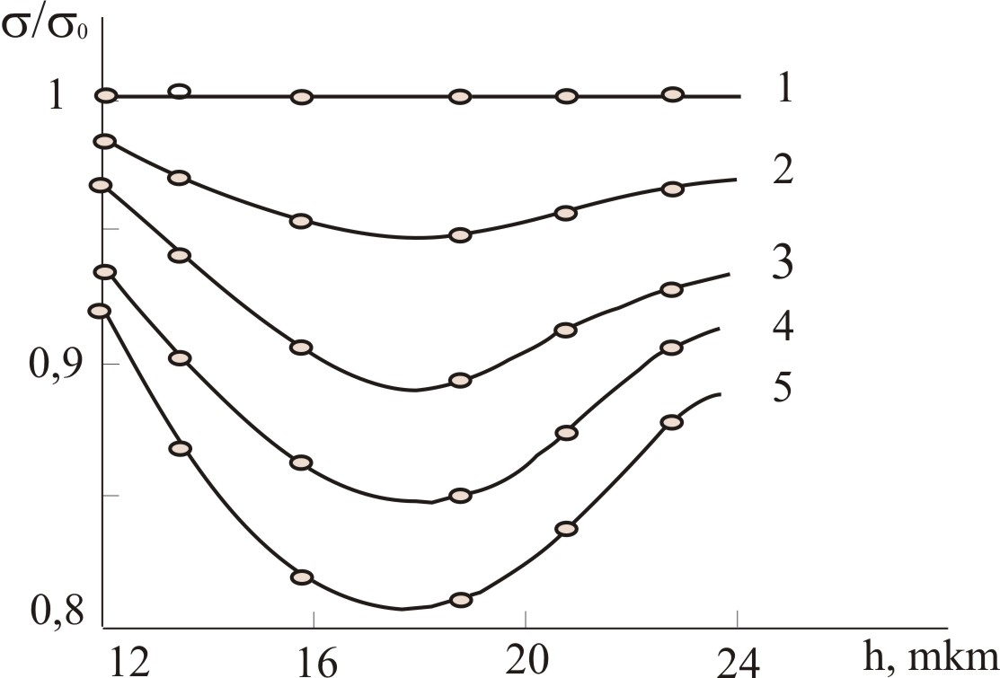
Fig.1. Experimental dependence of relative specific conductivity σ/σ₀ of p-PbTe films from thickness h: 1 – initial data and after irradiation by α−particles flood of Ф·10⁻¹² cm⁻²: 2 - 0,3; 3 - 0,6; 4 - 0,9; 5 - 1,2. Points - experiment, lines - calculation.
Obtained experimental data can be explained by Gaussian distribution of defects in material at plane-parallel flood of α−particles with taken into account isotropy of radiation of plane source. As a specific resistance is measured at transmission of current in parallel a film surface, then
ρ(x)=ρ₀+k Ф F(x),
where ρ₀ – initial specific resistance, Ф – flood of particles, k – coefficient of change of specific resistance on unit of size of flood, F(x) – distribution of defects on depth.
For chosen geometry of experiment F(x) will be:
$F(x)=\frac{2}{\sqrt{2p}d}\int_{0}^{1}{e^{−\frac{{\left(x\text{/cos}q−x_{0}\right)}^{2}}{2d}}}d\text{cos}q$,
where θ - angle of incidence of particles on surface of sample: х₀ and δ - average depth and standard deviation for Gaussian profile of defects distribution.
Unknown parameters were found from approximation of experimental values of conductivity (fig.1.) by dependence:
,
by least squares method.
As a result were obtained such values х₀ = 18 mkm, δ = 2 mkm, k = 10¹³ Оm· сm³. Distribution F(x) on depth of a film at α-irradiation with obtained parameters is shown in Fig.2. Notice that curves of approximation are in good agreement with experimental data. It testifies about possibility of definition of profile of radiation defects in offered way.
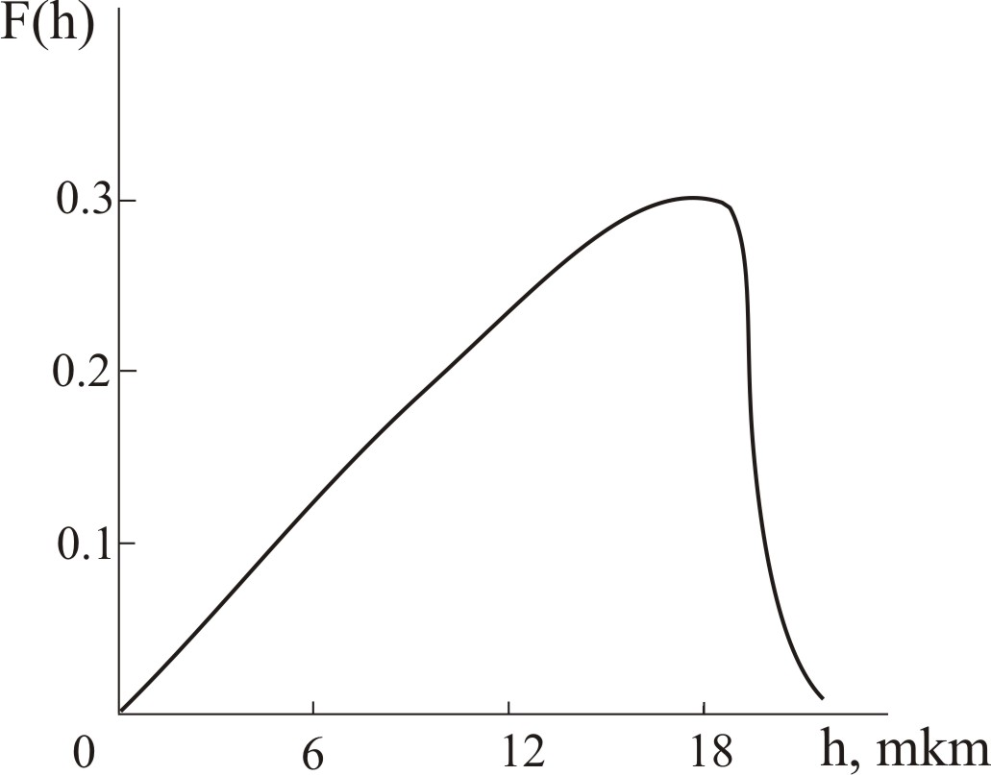
Fig.2. Calculated profile of distribution of defects on depth of a film at α-irradiation by isotropic floods.
Ionization and nuclear energy loss of α-particles in A^{IV}B^{VI}
- Path of α-particles in A^{IV}B^{VI}
In [3] is shown empirical calculation formula of path of α-particles:
R_{α }= 0,1 E_{α}(E_{α} A)1/2,
where R_{α} measure in mg/cm², E_{α} − MeV, A – atomic number. In Fig.3. is shown plots of dependence of free path from energy of particle in Pb, Te, Sn, Se. Path of α-particles with energy 5,5 MeV, that also were presented in Fig.3., were taken from tables [4]. Deviations in data from two sources are less then 5%.
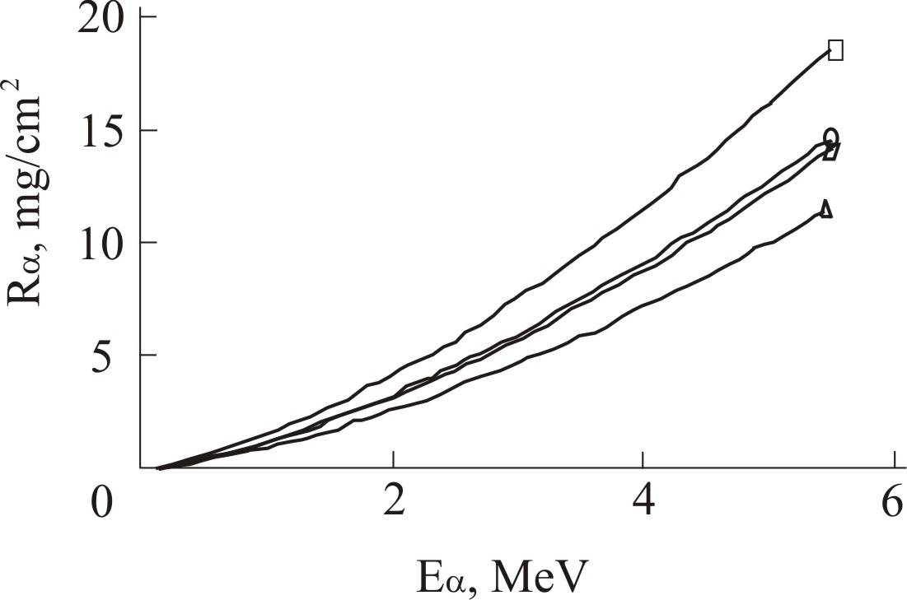
Fig.3. Path of α-particles calculated from empirical formula and that taken from tables in dependence from initial energy in Se - 1, Sn - 2, Te - 3 і Pb – 4.
Path of particle in compound AB find from formula [4]:
R_{AB} = (A_{A}+A_{B})/(A_{A}/R_{A}+A_{B}/R_{B}).
Dependences of path values from energy of particles with taken into account densities of compounds are shown in Fig.4.

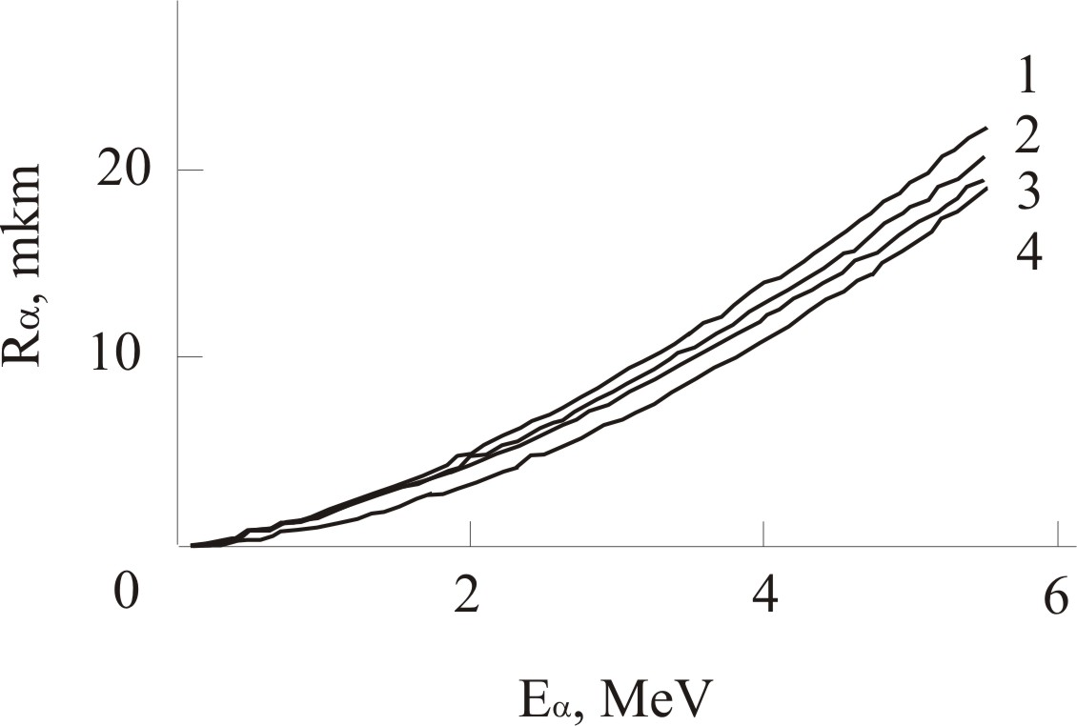
Fig.4. Path of α-particles in dependence from initial energy of particles in SnTe - 1, PbSe - 2, PbTe - 3 and photoemulsion- 4.

To confirm shown above path of α-particles R_{α} with energy E_{α} in dense condensed medium use another empirical formula [5]:
E_{α} =α (m_{α} /m_{p})^{1- n} Z_{α}^{2n} R_{α}^{n},
where parameters of dependence, for photoemulsion α = 0,25 , n = 0,58, m_{α}/m_{p} = 4, z_{α} = 2 —characteristics of particle. Path expresses by the formula:
R_{α}=(E_{α} /4α)^{1/ n}, mkm.
This dependence also is shown in Fig.4. We can see similarity of dependences and calculated values.
- Ionization loss of α-particles in A^{IV}B^{VI}
In range of energies, when speeds of ions are compared to speeds of atomic electrons, theoretical consideration of ionization loss is absent. In this range of speeds inelastic loss of energy have maximum. At calculations of transport of ions of intermediate energy in material often use cross-linking of values obtained from Linhard-Sharf formula [6] for low energies and Bethe-Bloch formula [7] for high energies.
However, loss of energy that calculated from formula (1)
-dE_{α}/dx = 2/3 (A/E_{α})^{1/2} N /N_{A}, МеV/mkm,
is monotone decreasing function of energy , where N – atom concentration. For α-particles maximum of stopping power is in range of energies, that intensively use experimentally, ~1 MeV. On base of a big amount of experimental data interpolation dependence [8]:
S_{e} = 0,235 Z Z_{α}² T^{0,6} ln(b(T²+0,01 Z+0,08)/(T+0,003 Z+0,024))/(T^{1,6}+a),
-dE_{α} /dx = S_{e} N,
where Z – order number of atom, T = E_{α}/4, E_{α} - energy of α-particles in MeV; a, b – changeable parameters, that in [8] selected so to provide optimal agreement with experiment. Cross section of stopping of α-particles in materials S_{e} is expressed in units 10⁻¹⁵ eV·cm²/atom. Fitting parameters a and b for components of compounds are represented in table 1. Calculated (with using (7)) energies of α-particles and ionization loss along path for initial energy of particles 5,5 MeV are represented in Fig.5. From figure we see, that maximum of loss is in the end of path and in about 2 times exceeds loss in the beginning.
Fig.5. Energies and ionization loss of α-particles along path for initial energy of particles 5,5 MeV of source Pu²³⁸ in PbSe - 1, PbTe - 2 and SnTe - 3.

- Nuclear loss of α-particles in A^{IV}B^{VI}
For normalized nuclear stopping power is used analytical expression from works [6, 9]:
S_{n}’= 0,5 ln(1+1,1383ε)/(ε + 0,01321 ε^{0,21226} + 0,1959 ε^{0,5}), (8)
where
ε = E_{α} a_{b} M / (1,13 Z Z_{α}(Z_{α}^{2/3} + Z^{2/3})^{1/2} e²(M_{α} + M)) , (9)
where a_{b} – Bohr radius. Value of stopping power in maximum is equal
S_{n} = 3,62 N a_{b} Z Z_{α} M_{α} e²/ ( (Z_{α}^{2/3} + Z^{2/3})^{1/2} (M_{α} + M)) erg/cm. (10)
In Fig.6. are represented nuclear loss in sublattices of metal and chalcogen for PbSe, PbTe and SnTe. From picture we see, that maximums of loss are in order bigger than loss along all trajectory and that loss on more heavy elements of compound are closer to surface of sample.
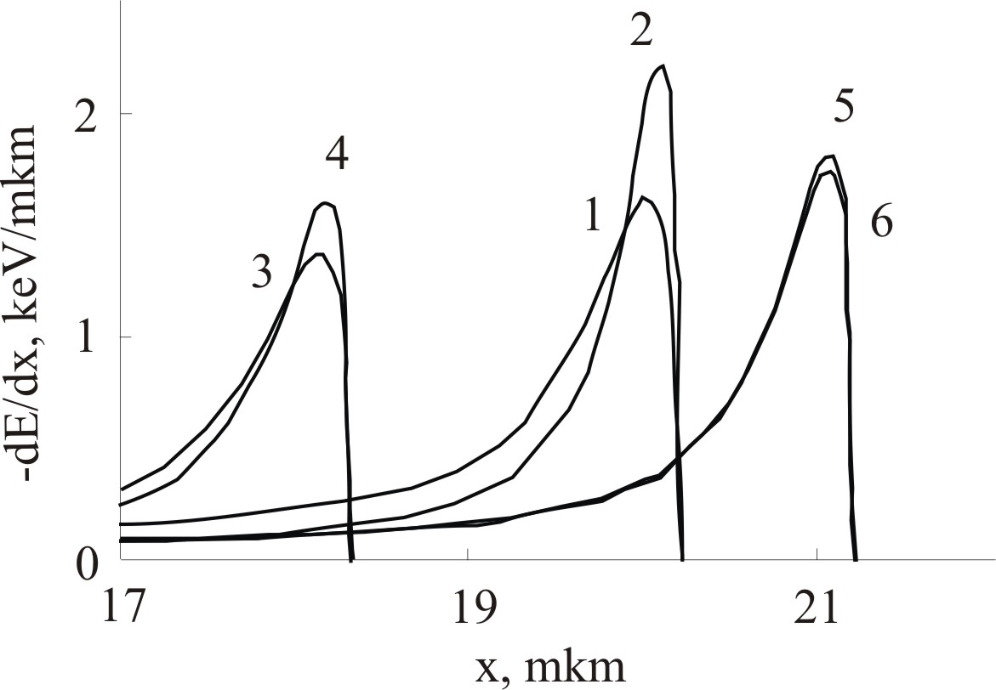
Fig.6. Nuclear energy loss of α-particles in sublattices of metal (1, 3, 5) and chalcogen (2, 4, 5) for initial energy of particles 5,5 MeV in PbSe - 1, 2; PbTe - 3, 4 and SnTe - 5, 6.
Thus, ionization loss of α-particles in A^{IV}B^{VI} are featured with using the dependence, that was presented in [8], with parameters selected by us, also was calculated nuclear loss. Nuclear loss, that responds for defect formation, on three orders less than ionization loss.
Was shown, that profile of distribution of radiation defects is the sum of Gaussian distributions for plane-parallel floods, which give isotropic flood. Parameters of Gaussian distribution are: average depth х₀ = 21 mkm, standard deviation δ = 2 mkm.
Table 1.
Selected fitting parameters for dependence of ionization loss
 | Pb | Te | Sn | Se
a | 0,18 | 0,15 | 0,15 | 0,10
b | 2,3 | 3,3 | 3,3 | 4,2

1. Nikerov V. A. Application of particles and radiations of high energies. — М: High school, 1988.- 152.
2. Laboratory practical work on experimental methods of nuclear physics. Under the editorship of K.G.Finogenova. — М: Energyatompublish, 1986. 432.
3. Jafarov K.G Radiation-stimulative diffusion in semiconductors. — М: Energyatompublish, 1991. - 220.
4. Nemec O.F., Hoffmann Ju.V. Directory on the nuclear physics. — Kiev: Science thuoght, 1975.414.
5. Mukhin K.N. Introduction in the nuclear physics. — М: Science, 1975.584.
6. Lizunov Ju.D., Ryazanov A.K. Research of stopping charged particles and formation of dot defects. — М: Pre-print. Institute of nuclear energy, 1988.36.
7. Ahiezer I.A., Davydov L.N. Introduction in the theoretical radiating physics of metals and alloys. — Kiev: Science thought, 1975. 250.
8. Pucherov N.N., Chesnokova T.D. Stopping power of metals for charged particles of low energies// Questions of a nuclear science and technics. — 1979. — №1, Release 9. — P.10-12.
9. Biersack J.P. Computer Simulations of Sputtering//Nuclear Instruments and Methods in Physics Research. — 1987. — B27. — P. 21-36.

